**Department of Electrical Engineering**

|  |  |
| --- | --- |
| **Faculty Member**: **Ma’am Qurat-ul-ain** | **Dated: October 23, 2020** |
|  |  |
| **Course/Section: BSCS-9B** | **Semester: 3rd** |
|  |  |

**Computer Organization and**

**Assembly Language (CS235)**

**Lab #2 Data Types in Assembly Language**

|  |  |  |  |  |  |  |  |
| --- | --- | --- | --- | --- | --- | --- | --- |
|  | | **PLO4** | | **PLO5** | **PLO8** | **PLO9** |  |
| **Name** | **Roll number** | **Viva /Quiz/ Lab performance**  **5 marks** | **Analysis of data in lab report**  **5 marks** | **Modern tool Usage**  **5 marks** | **Ethics and Safety**  **5 marks** | **Individual and team work**  **5 marks** | **Total**  **25 marks** |
| **Fatima Seemab** | **291310** |  |  |  |  |  |  |
| **Mahum Samar** | **290647** |  |  |  |  |  |  |
| **Maryam Fatima** | **290479** |  |  |  |  |  |  |

**Objective:** The aim of this lab is to understand specialized purpose of general-purpose registers and to practice declaring and manipulating variables in assembly language programs and verifying the outputs.





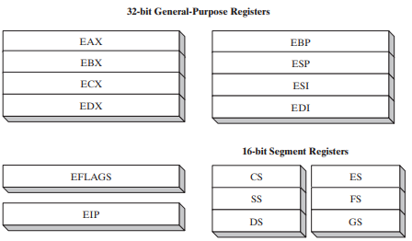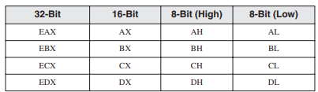

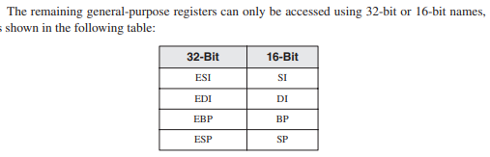

**Assignment 1 of coal Lab: (Deadline 31 October)**

Write small detail of each of 8 general purpose register. Assignment should not greater than 2 pages. Assignment submission is in group.

(4 lines + example)for each

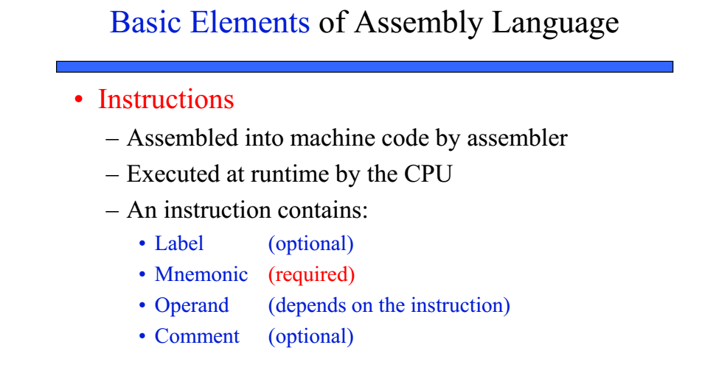

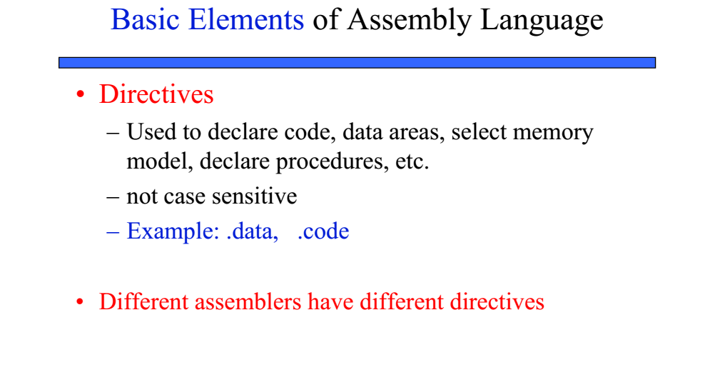

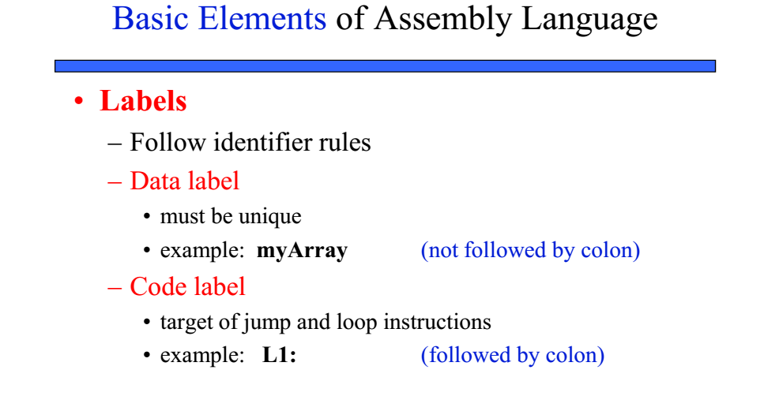

** **

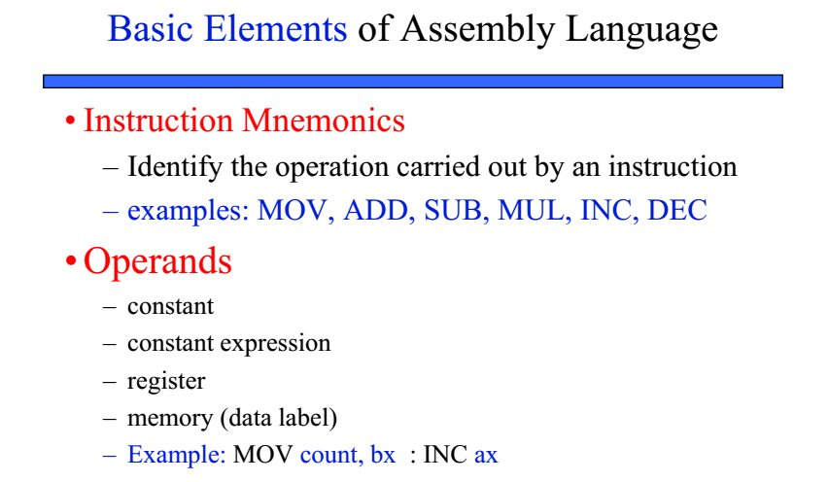

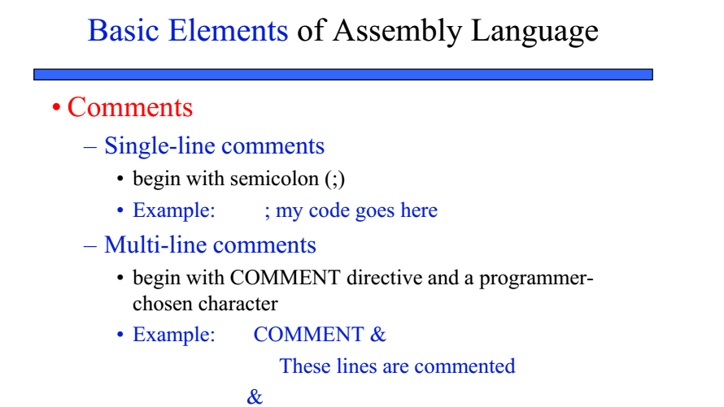

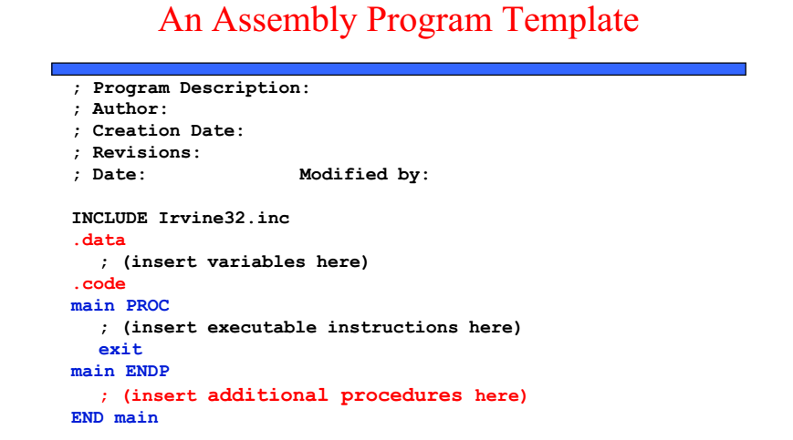

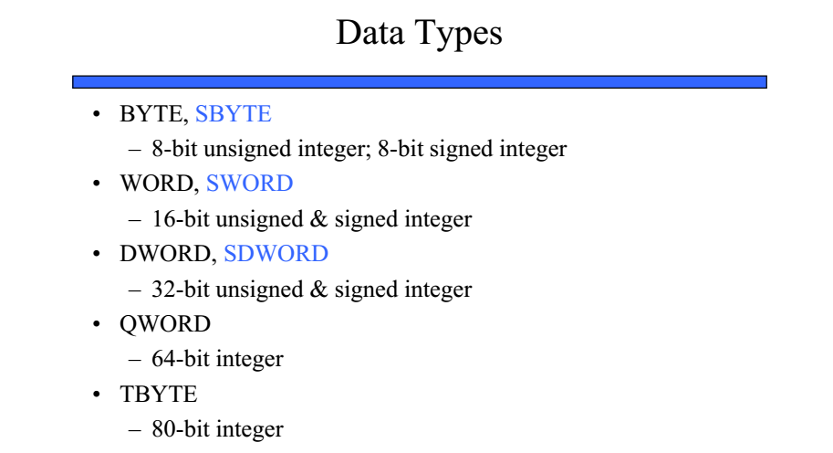

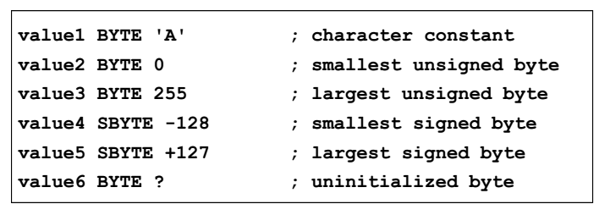

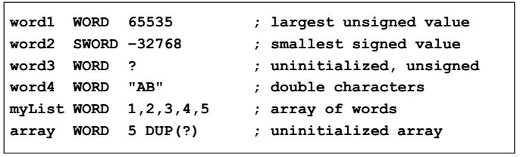

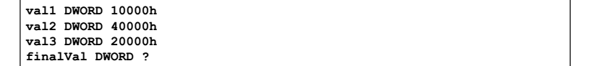

**Exercise 1:** Assemble and run the following program.

**Program**

TITLE Add and Subtract, (AddSub2.asm)

; This program adds and subtracts 32-bit unsigned

; integers and stores the sum in a variable.

INCLUDE Irvine32.inc

.data

val1 DWORD 10000h ; val1 declared as a variable of type DWORD and initialized

val2 DWORD 40000h

val3 DWORD 20000h

finalVal DWORD ?

.code

main PROC

mov eax,val1 ; start with 10000h

add eax,val2 ; add 40000h

sub eax,val3 ; subtract 20000h

mov finalVal,eax ; store the result (30000h)

call DumpRegs ; display the registers

exit

main ENDP

END main

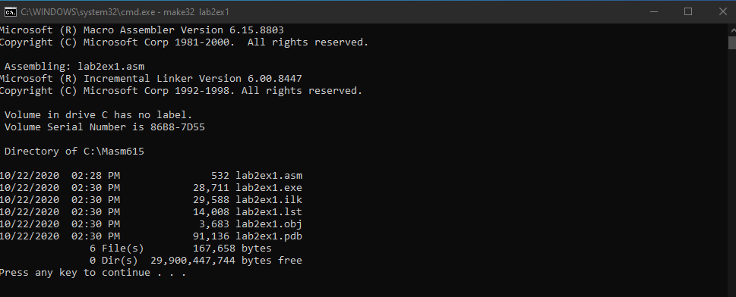

**Exercise 2:** Note down the contents of registers EAX, EBX and ECX as displayed by the program. Do the registers contents match the expected results?

EAX = 00030000

EBX = 0023B000

ECX = 00401005

Yes, the registers content matches the expected result. EAX contains 00030000, the calculated hexa-decimal value. While EBX and ECX contain garbage values as the two registers are not used in the program.

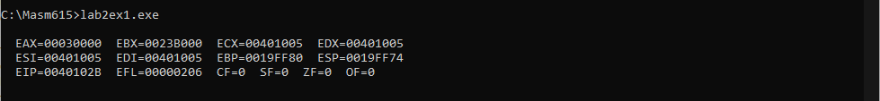

**Exercise 3:** Write code to achieve the following:

1. Define two 8-bit variables var1, and var2, and initialize these to 20, and 30.
2. Swap the contents of var1 and var2 variables using registers.
3. Display the contents of the registers. (Use “call dumpregs” instruction twice, First display variable before swapping, then display variable after swapping)

**Program**

TITLE Swap the content of variables using register, (lab2ex3.asm)

; This program swaps 8-bit unsigned integers in

; registers and displays swapped values.

INCLUDE Irvine32.inc

.data

var1 BYTE 20 ; var1 declared as a variable of type BYTE and initialized

var2 BYTE 30

.code

main PROC

mov eax,20 ; store var1 in eax

mov ebx,30 ; store var2 in ebx

call DumpRegs ; display the registers

mov cl, bl ; move var2 value to cl, using cl as temporary location

mov bl, al ; move var1 value to var2

mov al, cl ; finally move var2 stored in cl to var1 stored in al

call DumpRegs ; display the registers

exit

main ENDP

END main

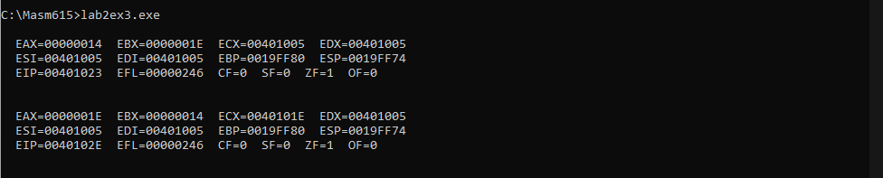

**Exercise 4:** Write codes to evaluate the arithmetic expression “5+(6-2)”, by:

1. Using one register only
2. Using two registers only

Write down the source codes below.

**Using one register only:**

A single register (EAX) is initialized and its least significant 8 bits are used.

**Program**

TITLE evaluate the arithmetic expression 5 + (6-2), (lab2ex4a.asm)

; This program adds and subtracts 8-bit unsigned

; Integers and stores the sum using one register only.

INCLUDE Irvine32.inc

.data

.code

main PROC

mov eax,6

sub al,2

add al,5

call DumpRegs ; display the registers

exit

main ENDP

END main

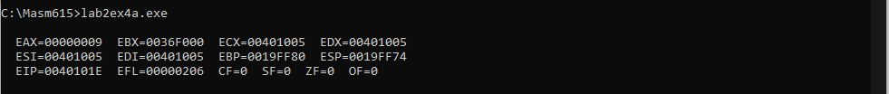

**Using two registers only:**

Registers EAX and EBX are initialized and then their least significant 8 bits are used.

**Program**

TITLE evaluate the arithmetic expression 5 + (6-2), (lab2ex4b.asm)

; This program adds and subtracts 8-bit unsigned

; Integers and stores the sum using two registers only.

INCLUDE Irvine32.inc

.data

.code

main PROC

mov eax,6

sub al,2

mov ebx,5

add al,bl

call DumpRegs ; display the registers

exit

main ENDP

END main

